Using redis sorted set

1. A redis leaderboard consumer here

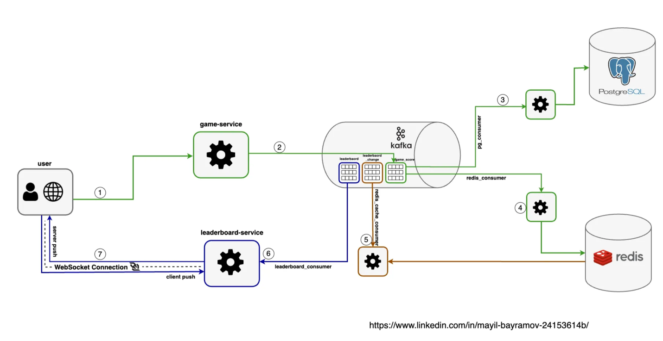

Key services

1. Game service

2. Leaderboard service

3. pg_consumer service (for writign to pg db)

4. redi_consumer service (for writing to redis)

Why do we need a game service?

Because of middle man attack here,

In the alternative design, the score is set by the client. This option is not secure because it is subject to man-in-the-middle attack [x], where players can put in a proxy and change scores at will. Therefore, we need the score to be set on the server-side.

Backend calculation:

1. daily active users)/(24*60*60) => 10 000 000/24*60*60 ≈ 115 RPS (request per second)

2. The above is important here

API design section

**API design**

At a high level, we need the following three APIs:

**POST /v1/scores**

Update a user’s position on the leaderboard when a user wins a game. The request parameters are listed below. This should be an internal API that can only be called by the game servers. The client should not be able to update the leaderboard score directly.

| **Field** | **Description** |
| --- | --- |
| user_id | The user who wins a game. |
| points | The number of points a user gained by winning a game. |

Table 1

Response:

| **Name** | **Description** |
| --- | --- |
| 200 OK | Successfully updated a user’s score. |
| 400 Bad Request | Failed to update a user’s score. |

Table 2

**GET /v1/scores**

Fetch the top 10 players from the leaderboard.

Sample response:

{

"data": [

{

"user_id": "user_id1",

"user_name": "alice",

"rank": 1,

"score": 12543

},

{

"user_id": "user_id2",

"user_name": "bob",

"rank": 2,

"score": 11500

}

],

...

"total": 10

}

**GET /v1/scores/{:user_id}**

Fetch the rank of a specific user.

| **Field** | **Description** |
| --- | --- |
| user_id | The ID of the user whose rank we would like to fetch. |

Table 3

Sample response:

{

"user_info": {

"user_id": "user5",

"score": 1000,

"rank": 6,

}

}

Database section

On the database side what do we need?

1. User_score table

Id, user_id, score, created_at

2. Users table

Id, nickname, full_name

The native solution:

1. Why using native sql query would not work:

select user_id, sum(score) as sum  
from user_score  
group by user_id  
order by sum desc  
limit 10;

If execution of the above query takes more than 450 ms, (extra +50 ms I reserve for service processing+network latency) we will not be able to achieve our goal.

Better solution

Redis sortedSet collection:

2. Redis **SortedSet** is a collection of unique strings (members) ordered by an associated score. You can think of sorted sets as a mix between a Set and a Hash. Like sets, sorted sets are composed of unique, non-repeating string elements, so in some sense, a sorted set is a set as well.

**1. Add element operation**

**add an elemen**t Redis performs an **O(log(N))** operation.

127.0.0.1:6379> ZINCRBY leader_board 15 'user-1'  
"15"  
127.0.0.1:6379> ZINCRBY leader_board 20 'user-1'  
"35"  
127.0.0.1:6379> ZINCRBY leader_board 36 'user-2'  
"36"

2. Query operation

**ZRANGE key start stop** — By default, the command performs an index range query. The <start> and <stop> arguments represent zero-based indexes, where 0 is the first element, 1 is the next element, and so on. These arguments specify an inclusive range, so for example, ZRANGE myzset 0 1 will return both the first and the second element of the sorted set. **Time complexity: O(log(N)+M)** with N being the number of elements in the sorted set and M the number of elements returned.

//as collection is sorted in ASC way , we pas REV keyword to function   
//to get result in DESC sorted  
//query top 3 scored users  
  
127.0.0.1:6379> ZRANGE leader_board 0 2 WITHSCORES REV   
1) "user-2" //RANK-1 KEY  
2) "36" //RANK-1 VALUE  
3) "user-1" //RANK-2 KEY  
4) "35" //RANK-2 VALUE  
5) "user-5" //RANK-3 KEY  
6) "26" //RANK-3 VALUE

And then the above is it here

1

Using redis and then scale first

Freq to update leaderboard?

**Interaction between user and game service (step-1,2)**

In the system design diagram(diagram-1) you can see **step-1**isinteraction between **user** and **game-service**. In the real world application process is so: the user plays a game and if he/she wins in that case earns points(or $). The game provider service typically sends winning data or relevant game events to the client-side application. It might send sth every 2 seconds.

We can save this GameScore data to both PostgreSQL and Redis at the same time, no need to wait for both to complete. we are free to add Kafka broker between services to isolate PostgreSQL and Redis data save process independently. In conclusion will publish our game score data to game_score Kafka topic.

- The game service will publish data to the kafka broker as a producer here,   
The game service is where user is playing the game and the score is being generated

@Slf4j  
@Service  
@RequiredArgsConstructor  
public class GameScoreService {  
  
 private final ConfigProperties configProperties;  
 private final KafkaTemplate<String, GameScoreDto> kafkaTemplate;  
  
 @Scheduled(fixedRate = 1000)  
 public void randomGameScores() {  
 int batchSize = 2000;  
 for (int i = 0; i < batchSize; i++) {  
 publishGameScore();  
 }  
 }  
  
 public void publishGameScore() {  
 String gameScoreTopic = configProperties.getBrokerProperties().getGameScoreTopic(); //"game_score" topic  
 GameScoreDto gameScoreDto = buildGameScore();  
 //publish to kafka "game_score" topic  
 kafkaTemplate.send(gameScoreTopic, gameScoreDto.getUserId().toString(), gameScoreDto);  
 log.debug("game score of user - {} was published to kafka topic: {}", gameScoreDto, gameScoreTopic);  
 }  
  
 private GameScoreDto buildGameScore() {  
 Random random = new Random();  
 return GameScoreDto.builder()  
 .score(random.nextInt(100) + 1)  
 .userId(random.nextLong(1000_000) + 1)  
 .createdAt(LocalDateTime.now()).build();  
 }  
  
}

**PostgreSQL consumer of the game_score topic (step-3)**

We need a postgresl consumer service

In the system design diagram(diagram-1) you can see in the **step-3,**that**PostgreSQL** consumer service consumes data fromgame_score topic and save it to the PostgreSQL database.

@Slf4j  
@Component  
@RequiredArgsConstructor  
public class GameScorePgConsumer {  
  
 private final GameScoreRepo gameScoreRepo;  
  
 @KafkaListener(  
 topics = {"${application.config.broker-properties.game-score-topic}"} , //game_score topic  
 groupId = "${application.config.broker-properties.game-score-topic-pg-consumer-group-id") //pg_consumer  
 public void gameScorePgConsumer(ConsumerRecord<String, GameScoreDto> record){  
 var scoreDto = record.value();  
 log.debug("record consumed , userId: {}, score: {}", record.key(), scoreDto.getScore());  
 //map GameScoreDto to database entity  
 GameScore gameScore = GameScore.builder()  
 .userId(scoreDto.getUserId())  
 .score(scoreDto.getScore())  
 .createdAt(scoreDto.getCreatedAt()).build();  
 //save game score in postgresql database  
 gameScoreRepo.save(gameScore);  
 log.debug("record saved to db , key: {}", record.key());  
 }  
}

**Redis consumer of the game_score topic (step-4)**

In this step, redis consumer of game_score Kafka topic will consume data

1. increment user’s score in Redis sorted set collection
2. publish change timestamp event to leaderboard_change topic.

If the user gets a new point, the current leaderboard may change. We need to update leaderboard in user interface when the leaderboard changed. Therefore we need leaderboard_change topic to publish this change *timestamp (I will explain later why we need only a timestamp for this event change)* to that topic at the same time.

The diagram (system-design-2) below visualizes this process

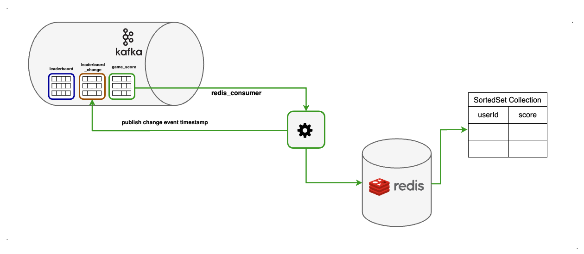

system-design-2

In our case redis sorted set collection key is leader_board (you can also create many leaderboards based on different qualifications) . SortedSet will sort our userId based on their score .

Implementation section you can find below the code snippet

@Slf4j  
@Component  
@RequiredArgsConstructor  
public class GameScoreRedisConsumer {  
  
 private final RedisTemplate<String, String> redisGameScoreTemplate;  
 private final KafkaTemplate<String, LeaderBoardChangeDto> kafkaLeaderboardChangeTemplate;  
 private final ConfigProperties configProperties;  
  
  
 @KafkaListener(  
 topics = {"${application.config.broker-properties.game-score-topic}"}, //game_score topic  
 groupId = "${application.config.broker-properties.game-score-topic-redis-consumer-group-id}" //redis_consumer  
 )  
 public void gameScoreRedisConsumer(ConsumerRecord<String, GameScoreDto> record) {  
 var gameScore = record.value();  
 var score = gameScore.getScore();  
 var leaderboardCollectionKey = configProperties.getRedisProperties().getLeaderBoardKey(); //"leader_board"  
  
 log.debug("record consumed , userId: {}, score: {} ", gameScore.getUserId(), score);  
 //increment user's score in redis sortedset collection  
 redisGameScoreTemplate.opsForZSet().incrementScore(leaderboardCollectionKey, gameScore.getUserId().toString(), score);  
  
 log.debug("record with userId: {} , score : {} added to redis set", gameScore.getUserId(), score);  
  
 //publish record timestamp to "leaderboard_change" event  
 kafkaLeaderboardChangeTemplate.send(configProperties.getBrokerProperties().getLeaderboardChangeTopic(),  
 new LeaderBoardChangeDto(getTimestampMs(gameScore.getCreatedAt())));  
  
 log.debug("record with userId: {} , score : {} change timestamp published to kafka", gameScore.getUserId(), score);  
 }

**Consumer service of the leaderboard_change topic (step-5)**

At the outset of the blog, we highlighted that real-time updates would be applied to the leaderboard. That means in every change we will update leaderboard. But wait ….. we have 1150 requests per second, does it make sense to send 1150 updates in per second to UI which every user has connected it? *This would be impractical and could potentially overwhelm the UI and the connected users with a high volume of updates.*

In our design, we will implement throttling and caching mechanisms to manage and control the frequency of leaderboard updates effectively.  
We’ll establish a throttle duration, such as 2000 ms (you can adjust it based on your need), which signifies that updates to the leaderboard will be dispatched to UI users within this specified time interval. We will also cache each leaderboard update in another *Redis Key-Value based* collection (which is lookup is O(1)).

Here are the following steps:

1. Upon consuming each record from the leaderboard_change topic, we’ll initially assess the timestamp of the record.

2. We’ll then compare this timestamp with the cached leaderboard’s last update timestamp.

3. If the time interval between the two < 500 milliseconds, we will bypass processing this particular record change.

4. If the time interval > 500 milliseconds (the throttle duration), we will proceed to request the top 10 players from the Redis SortedSet leaderboard. Subsequently, we will cache this result in another Redis Key-Value store, ensuring efficient O(1) lookups.Following the caching process, we will publish the newly acquired leaderboard result to the Kafka leaderboard topic.

Balancing speed and memory considerations is essential. You can choose an option based on your system needs. In our system design, we have applied 1st option.

The diagram below demonstrates this process

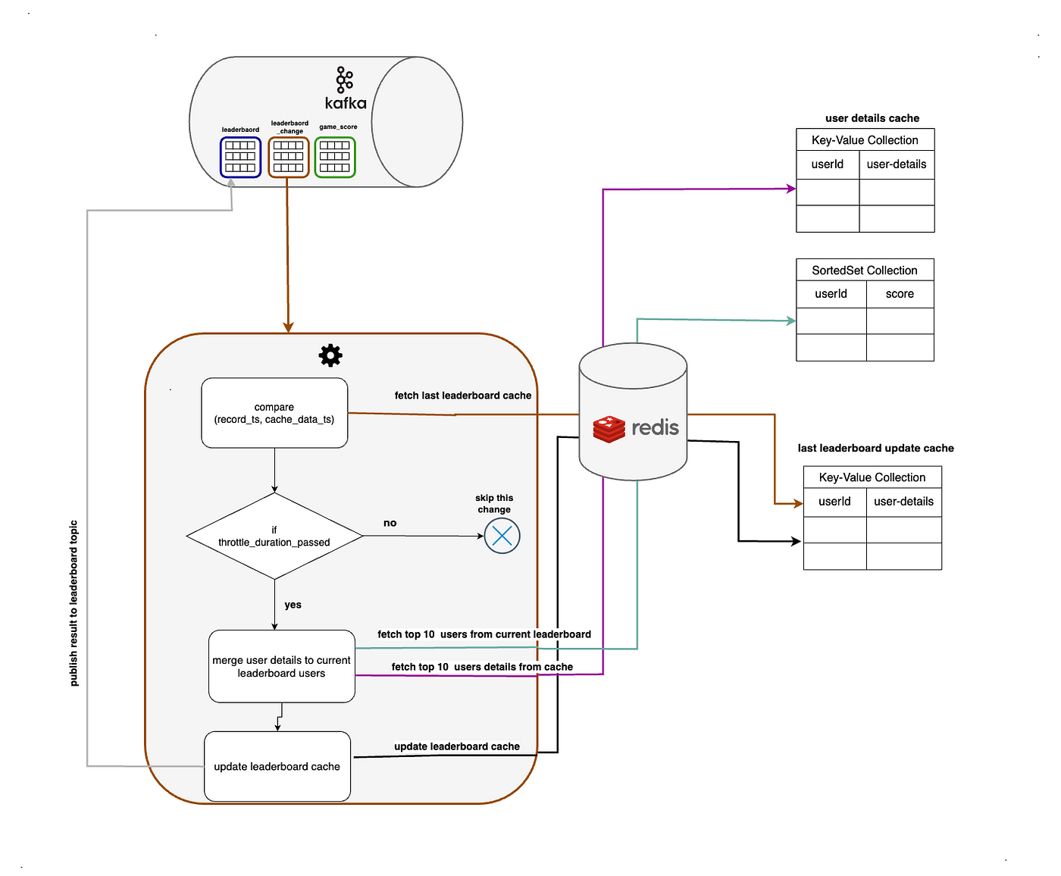

system-design-3

Implementation section you can find below the code snippet

@Slf4j  
@Component  
@RequiredArgsConstructor  
public class LeaderboardCacheConsumer {  
  
 private final RedisTemplate<String, String> redisGameScoreTemplate;  
 private final RedisTemplate<String, String> redisUserCacheTemplate;  
 private final RedisTemplate<String, LeaderBoardDto> redisLeaderboardCacheTemplate;  
 private final KafkaTemplate<String, LeaderBoardDto> kafkaLeaderboardTemplate;  
 private final ConfigProperties config;  
  
  
 @KafkaListener(  
 topics = {"${application.config.broker-properties.leaderboard-change-topic}"} , //leaderboard_change topic  
 groupId = "${application.config.broker-properties.leaderboard-change-topic-cache-consumer-group-id}" //leaderboard_cache_consumer  
 )  
 public void leaderboardCacheConsumer(ConsumerRecord<String, LeaderBoardChangeDto> record){  
  
 //throttle leaderboard update interval  
 var leaderBoardChange = record.value();  
 log.debug("record consumed with timestampMs: {}", leaderBoardChange.getRecordTimestampMs());  
  
 String cacheKey = config.getLeaderboardProperties().getLeaderboardCacheKey();  
 var leaderBoardCache = redisLeaderboardCacheTemplate.opsForValue().get(cacheKey);  
 long currentTimeMs = System.currentTimeMillis();  
  
 //check if throttle timestamp hasn't passed just skip this update  
 if (!canRefreshLeaderboard(leaderBoardCache, currentTimeMs)){  
 log.debug("leaderboard cache update skipped , reason: throttle duration hasn't passed ,currentTs: {}, cacheTs: {}",  
 currentTimeMs, leaderBoardCache != null ? leaderBoardCache.getLastModifyTimestamp() : null );  
 return;  
 }  
  
 // get current leaderboard top 10 users from sortedset and update leaderboard cache & send this update to "leaderboard" topic  
 Set<ZSetOperations.TypedTuple<String>> leaderBoard = redisGameScoreTemplate.opsForZSet().reverseRangeWithScores("leader_board", 0, 9);  
  
 if (Objects.isNull(leaderBoard)){  
 log.debug("leaderboard cache update skipped , reason: current leaderboard is null, leaderboard change timestamp {}",  
 leaderBoardChange.getRecordTimestampMs());  
 return;  
 }  
  
 LeaderBoardDto leaderBoardUpdate = mapToLeaderboardDto(leaderBoard, currentTimeMs);  
  
 //update leaderboard cache which stores only top 10 users  
 redisLeaderboardCacheTemplate.opsForValue().set(cacheKey, leaderBoardUpdate);  
  
 //publish leaderBoard updated record to "leaderboard" kafka topic  
 kafkaLeaderboardTemplate.send("leaderboard", leaderBoardUpdate);  
  
 log.debug("leaderboard cache updated , updateTimestamp: {}", currentTimeMs);  
 }  
  
 private boolean canRefreshLeaderboard(LeaderBoardDto leaderBoardCache, long currentTimeMs){  
 // Calculate the timestamp threshold for throttling  
 long throttleThreshold = currentTimeMs - config.getLeaderboardProperties().getThrottleDurationInMs();  
  
 return Objects.isNull(leaderBoardCache) || throttleThreshold > leaderBoardCache.getLastModifyTimestamp();  
 }  
  
 private LeaderBoardDto mapToLeaderboardDto(Set<ZSetOperations.TypedTuple<String>> leaderBoard,  
 long currentTimeMs) {  
 int rank = 0;  
 List<LeaderBoardDto.User> userList = new ArrayList<>(leaderBoard.size());  
 for (ZSetOperations.TypedTuple<String> tuple : leaderBoard) {  
 String userId = tuple.getValue();  
 LeaderBoardDto.User user = LeaderBoardDto.User.builder()  
 .rank(++rank)  
 .score(tuple.getScore())  
 .nickname(getCachedNicknameByUserId(userId))  
 .build();  
 userList.add(user);  
 }  
 return new LeaderBoardDto(userList, currentTimeMs);  
 }  
  
 private String getCachedNicknameByUserId(String userId) {  
 return redisUserCacheTemplate.opsForValue().get(userId);  
 }  
}

I would also recommend to add additional check in this step to minimize the volume of leaderboard updates. I would suggest send leaderboard update in case of previous leaderboard userList changed . Create checksum for leaderboard cache, based on checksum(leaderboard(userId+score)) and save it in Redis together with leaderboard cache object.  
In the event of a checksum change, compare the existing leaderboard with the previously cached version, and dispatch leaderboard updates solely for users whose rankings have changed.

**How do we scale redis? (This part is from byte-byte-go) here**

Scaling redis here

**Scaling Redis**

With 5 million DAU, we can get away with one Redis cache from both a storage and QPS perspective. However, let’s imagine we have 500 million DAU, which is 100 times our original scale. Now our worst-case scenario for the size of the leaderboard goes up to 65 GB (650 MB *100), and our QPS goes up to 250,000 (2,500 * 100) queries per second. This calls for a sharding solution.

**Data sharding**

We consider sharding in one of the following two ways: fixed or hash partitions.

**Fixed partition**

One way to understand fixed partitions is to look at the overall range of points on the leaderboard. Let’s say that the number of points won in one month ranges from 1 to 1000, and we break up the data by range. For example, we could have 10 shards and each shard would have a range of 100 scores (For example, 1-100, 101-200, 201-300, ...) as shown in Figure 18.



Figure 18 Fixed partition

For this to work, we want to ensure there is an even distribution of scores across the leaderboard. Otherwise, we need to adjust the score range in each shard to make sure of a relatively even distribution. In this approach, we shard the data ourselves in the application code.

Using a 2nd cache

User_id -> score

When we are inserting or updating the score for a user, we need to know which shard they are in. We could do this by calculating the user’s current score from the MySQL database. This can work, but a more performant option is to create a secondary cache to store the mapping from user ID to score. We need to be careful when a user increases their score and moves between shards. In this case, we need to remove the user from their current shard and move them to the new shard.

To fetch the top 10 players in the leaderboard, we would fetch the top 10 players from the shard (sorted set) with the highest scores. In Figure 18, the last shard with scores [901, 1000] contains the top 10 players.

To fetch the rank of a user, we would need to calculate the rank within their current shard (local rank), as well as the total number of players with higher scores in all of the shards. Note that the total number of players in a shard can be retrieved by running the “*info keyspace*” command in *O(1)* [10].

**Hash partition**

A second approach is to use the Redis cluster, which is desirable if the scores are very clustered or clumped. Redis cluster provides a way to shard data automatically across multiple Redis nodes. It doesn’t use consistent hashing but a different form of sharding, where every key is part of a **hash slot**. There are 16384 hash slots [11] and we can compute the hash slot of a given key by doing *CRC16(key) % 16384* [12]. This allows us to add and remove nodes in the cluster easily without redistributing all the keys. In Figure 19, we have 3 nodes, where:

* The first node contains hash slots [0, 5500].
* The second node contains hash slots [5501, 11000].
* The third node contains hash slots [11001, 16383].

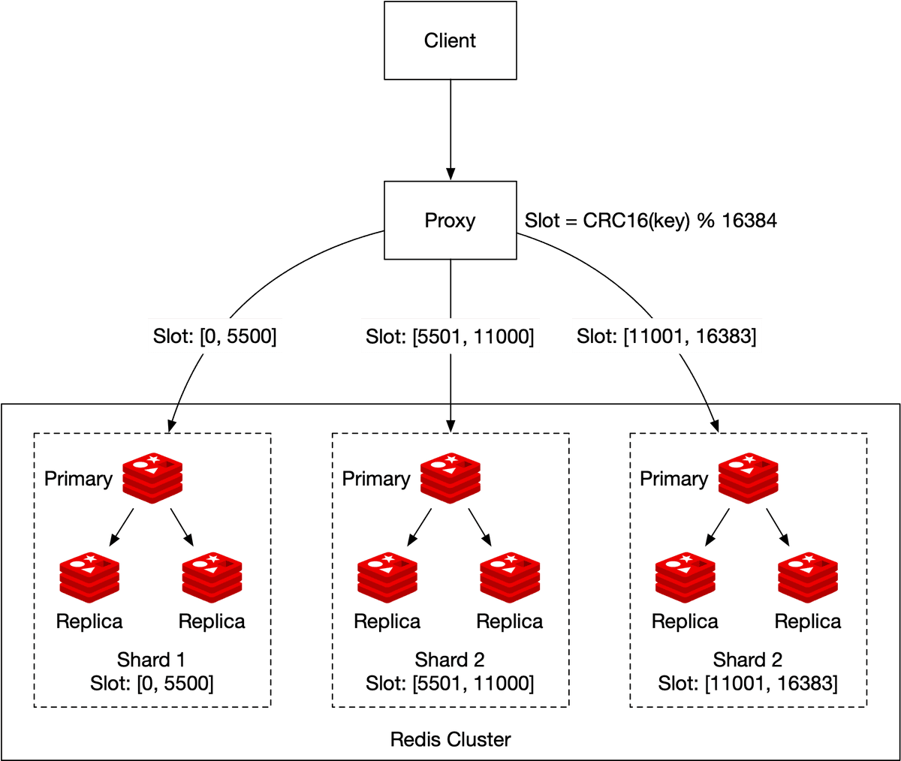

Figure 19 Hash partition

An update would simply change the score of the user in the corresponding shard (determined by *CRC16(key)%16384*). Retrieving the top 10 players on the leaderboard is more complicated. We need to gather the top 10 players from each shard and have the application sort the data. A concrete example is shown in Figure 20. Those queries can be parallelized to reduce latency.

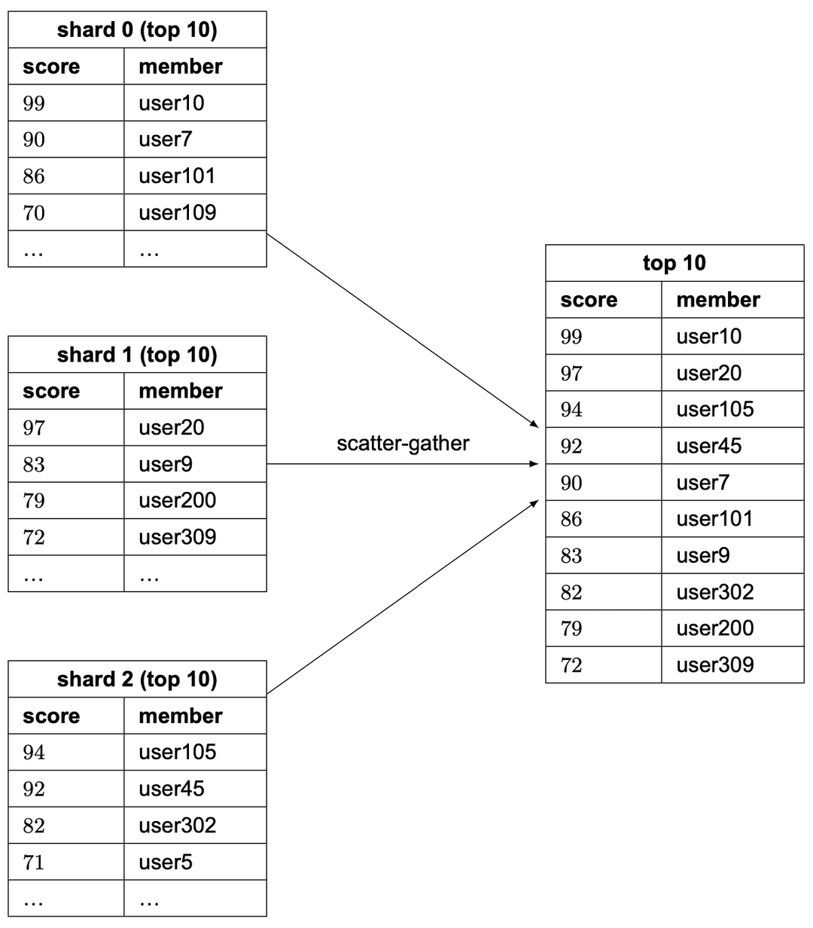

Figure 20 Scatter-gather

This approach has a few limitations:

* When we need to return top K results (where K is a very large number) on the leaderboard, the latency is high because a lot of entries are returned from each shard and need to be sorted.
* Latency is high if we have lots of partitions because the query has to wait for the slowest partition.
* Another issue with this approach is that it doesn’t provide a straightforward solution for determining the rank of a specific user.

Therefore, we lean towards the first proposal: fixed partition.

**Sizing a Redis node**

There are multiple things to consider when sizing the Redis nodes [13]. Write-heavy applications require much more available memory, since we need to be able to accommodate all of the writes to create the snapshot in case of a failure. To be safe, allocate twice the amount of memory for write-heavy applications.

Redis provides a tool called Redis-benchmark that allows us to benchmark the performance of the Redis setup, by simulating multiple clients executing multiple queries and returning the number of requests per second for the given hardware. To learn more about Redis-benchmark, see [14].

**Communication between Frontend and Backend Service(step-6, 7)**

**WebSocket** communication is preferred for real-time updates due to its persistent, bidirectional, and low-latency nature. Unlike traditional HTTP, which involves opening a new connection for each request, WebSocket enables a continuous connection between the client and server, allowing instant data transmission in both directions. This persistent connection significantly reduces latency and facilitates real-time communication, making it ideal for applications requiring rapid and continuous updates, such as live chats, online gaming, and dynamic dashboards.

Create leaderboard-ws service and configure a messaging broker with the /live-updates prefix. When UI users initiate a websocket connection, they can subscribe to any websocket channel prefixed with /live-updatesto receive real-time updates from the leaderboard.

@Configuration  
@EnableWebSocketMessageBroker  
public class WebSocketConfig implements WebSocketMessageBrokerConfigurer {  
  
 @Override  
 public void configureMessageBroker(MessageBrokerRegistry config) {  
 config.enableSimpleBroker("/live-updates");  
 config.setApplicationDestinationPrefixes("/app");  
 }  
  
 @Override  
 public void registerStompEndpoints(StompEndpointRegistry registry) {  
 registry.addEndpoint("/online-game");  
 }  
  
}

Consume /leaderboard kafka topic and broadcast leaderboard changes to the WebSocket broker. Users who have subscribed via the webpage will receive these real-time leaderboard updates. The following code snippet illustrates this scenario.

@Slf4j  
@Component  
@RequiredArgsConstructor  
public class LeaderBoardConsumer {  
  
  
 private final SimpMessagingTemplate simpMessagingTemplate;  
  
  
 @KafkaListener(  
 topics = {"${application.config.broker-properties.leaderboard-topic}"}, //leaderboard kafka topic  
 groupId = "${application.config.broker-properties.leaderboard-topic-ws-consumer-group-id}") // leaderboard_ws_consumer  
 public void leaderboardWsConsumer(ConsumerRecord<String, LeaderBoardDto> record){  
 var leaderboard = record.value();  
 log.debug("leaderboard record consumed , timestamp: {} ", leaderboard.getLastModifyTimestamp());  
 //broadcast leaderboard changes to the websocket broker which users has subscribed it via webpage  
 simpMessagingTemplate.convertAndSend("/live-updates/leaderboard", leaderboard);  
 }  
}

*Based on your load you can run your****websocket****server in****cluster mode****with****an external broker****. If you are interested in this topic, follow&subscribe my Medium channel I will share post related to this topic in future blog.*

**Establishing a connection from the frontend to our WebSocket channel**

We’ll create a webpage connection to our websocket channel using JavaScript(SockJS). Additionally, I’ve implemented an extra REST endpoint, /leaderboard which will be invoked during the initiation of the WebSocket connection through the webpage. This endpoint loads the cached leaderboard from Redis. Upon receiving a leaderboard update from the WebSocket server, the existing leaderboard will be replaced with the new data. The following code snippet illustrates this scenario.

const stompClient = new StompJs.Client({  
 brokerURL: 'ws://localhost:8082/online-game'  
});  
  
stompClient.onConnect = (frame) => {  
 loadLeaderboardCache()  
 console.log('Connected: ' + frame);  
 stompClient.subscribe('/live-updates/leaderboard', (res) => {  
 showLeaderboard(JSON.parse(res.body));  
 });  
};  
  
stompClient.onWebSocketError = (error) => {  
 console.error('Error with websocket', error);  
};  
  
stompClient.onStompError = (frame) => {  
 console.error('Broker reported error: ' + frame.headers['message']);  
 console.error('Additional details: ' + frame.body);  
};  
  
  
  
function connect() {  
 stompClient.activate();  
 console.log("ws connection established")  
}  
  
function disconnect() {  
 stompClient.deactivate();  
 console.log("ws connection disconnected");  
}  
  
  
function showLeaderboard(leaderboard) {  
 $('#lastModifiedDate').text(leaderboard.lastModifiedDate)  
 $("#leaderboard").empty();  
 let html = "<tr><th>rank</th><th>username</th><th>score</th></tr>"  
 // Iterate over userList and append each user's information  
 leaderboard.userList.forEach(function(user) {  
 // Construct the HTML for each user  
 html+= "<tr><td>" + user.rank + "</td><td>" + user.nickname + "</td><td>" + user.score + "</td></tr>";  
 });  
 // Append the HTML to #leaderboard  
 $("#leaderboard").append(html);  
}  
  
  
  
function loadLeaderboardCache() {  
 // URL of the REST API endpoint  
 const apiUrl = 'http://localhost:8082/leaderboard';  
  
 fetch(apiUrl)  
 .then(response => {  
 if (!response.ok) {  
 throw new Error('Network response was not ok');  
 }  
 console.log(response)  
 return response.json();  
 })  
 .then(data => {  
 console.log('leaderboard cache:', data);  
 showLeaderboard(data)  
 })  
 .catch(error => {  
 // Handle errors during the fetch operation  
 console.error('Error during fetch:', error);  
 });  
}

I’ve conducted testing on the web page, and the results are visible below.



leaderboard-web-page

**Appendix to step 7**

You can also utilize a client-side (JavaScript) polling method instead of WebSocket for real-time updates. However, it’s essential to bear in mind that polling introduces higher latency and increased server load compared to WebSocket

Thank you for taking the time to read my article! Follow & Subscribe for more articles

If you find this article helpful for you , your support such as **like, comment, sharing**likerocket fuel for my technology passion. It motivates me to dive deeper into the tech world and deliver more content that matters to you.

If you’re looking to offer more support, consider buying me a coffee, and I’ll transform that caffeine boost into lines of code and tech insights. Your coffee becomes the code that powers our tech journey. ☕💻🚀 <https://www.buymeacoffee.com/mayilb95>

**How does the UI get updated?**

Using websocket to receive update from leaderboard service like before on the frotnend

Our leaderBoardConsumer

Consume /leaderboard kafka topic and broadcast leaderboard changes to the WebSocket broker. Users who have subscribed via the webpage will receive these real-time leaderboard updates. The following code snippet illustrates this scenario

And this is important as said